SmartPass
A Multi-Modal Attendance and Emotional Wellness Monitoring System

Features of the Application, User Profile, and Graphical User Interface

ITS142P – Human-Computer Interaction 2
FOPM01· Group 9

Submitted by:
CABALLERO, Josel Henri L.
CAGATIN, John Viclouis P.
GAFFUD, Yra Geinna B.
JOCOM, Nathan Absalom C.

October 2, 2026

I. Project Overview
SmartPass is a web-based campus platform that brings together two responsibilities that are normally handled separately: recording whether students are physically present and noticing when they are not coping.
Attendance is captured automatically through RFID card taps. When a student taps in, the system identifies the class section, compares the time of the tap against the scheduled start time plus a configurable grace period, and records the student as present or late without any staff intervention. Thresholds are set per class section, so once a student accumulates enough absences or late arrivals, warnings are raised to both the student and the professor before the situation becomes unrecoverable.
Alongside this, students’ complete wellness check-ins. These can be a short, guided form in which they select a mood and tag what is contributing to it, or a multi-modal assessment that combines facial expression analysis, voice analysis and a combined evaluation. Each entry is assigned to a risk level, and guidance counselors work from a single triage view where the caseload can be filtered by severity and reviewed systematically rather than reactively.
Because attendance and wellbeing sit in the same system, a pattern of absences and a pattern of declining mood are visible to the same people at the same time, which is the point: the two are usually related, and institutions normally only connect them after an incident.
Access is governed by five roles: Student, Professor, Guidance Counselor, Academic Administrator and System Administrator, each with its own dashboard and permissions, so sensitive wellness data is visible only to those responsible for it.

II. Functions and Features
The system’s capabilities are grouped below by the area of the institution they serve.

1. Attendance Management
- RFID presence logging
- Students tap an RFID card at a reader and attendance is written against the matching class section automatically, with no manual roll call.
- Automatic status determination
- The system compares the scan time against the class start time plus a configurable late threshold and records the student as present or late without staff input.
- Per-course attendance records
- Each enrolled course keeps a running summary of present, late, absent and excused sessions, with an expandable dated breakdown of every session.
- Manual logging and correction
- Professors can record or amend an attendance entry by hand for a specific student and date when a reader is unavailable or a record is disputed.
- Absence threshold alerts
- Warning and critical thresholds are configured per class section; crossing one raises a notification to the student and the professor.
- Class attendance matrix
- A single view showing every enrolled student against every session held, color-coded by status, with per-student totals and attendance rates.

2. Emotional Wellness Monitoring
- Multi-modal wellness check-in
- Combines facial expression analysis, voice analysis and a combined AI assessment to estimate a student’s emotional state.
- Standard mood check-in
- A three-step guided form in which a student selects a mood, tags contributing factors such as academic stress or workload, and adds optional notes.
- Risk classification
- Each wellness entry is assigned to a risk level of normal, struggling or critical, derived from the reported mood and contributing factors.
- Counselor review and triage
- Counselors filter the caseload by risk level, isolate entries nobody has reviewed yet, and record an override risk level with private notes.
- Caseload analytics
- A risk distribution chart and an eight-week risk trend show how the assigned student population is moving over time.
- Counseling appointments
- Students request sessions and counselors approve, decline, reschedule, complete or cancel them, with a date and time captured on reschedule.

3. Communication
- In-app direct messaging
- Private threaded conversations between students and staff, including file and image attachments.
- Notifications
- Attendance breaches, wellness flags, appointment updates and new messages are surfaced in a notification center with read and unread states.
- Support ticketing
- Users raise tickets against categories such as accounts, attendance, technical or wellness, each with a priority and a status tracked to resolution.
- Broadcast announcements
- Administrators compose an announcement that is delivered to every user of the system at once.

4. Academic Administration
- Academic structure management
- Academic years, terms, departments, programs, sections, courses and class sections are each maintained from a single tabbed interface.
- Enrollment management
- Students are enrolled into or dropped from class sections individually, with their current enrollments listed alongside.
- Institution-wide reporting
- Dashboards covering attendance rate, total absences, wellness log volume and per-program performance, switchable between attendance and wellbeing views.
- Data export
- Attendance and wellness reports are exportable to CSV for offline analysis.

5. System Administration
- Role-based access control
- Five distinct roles: Student, Professor, Guidance Counselor, Academic Administrator and System Administrator each see only the screens and data their role permits.
- Account management
- Accounts are created, searched, filtered by role and deactivated from a central directory.
- Approval workflow
- Requests such as excused absences and enrollment overrides are routed for review, with the full request payload visible before a decision is recorded.
- Audit trail
- Every successful change to the system is logged with actor, action, category, severity and timestamp, and is filterable and exportable.
- System settings
- Maintenance mode, live alerts, automatic synchronization and a global RFID grace period are toggled centrally and take effect immediately.

6. Personalization
- Accent color
- Seven preset accent colors plus a custom picker accepting any hexadecimal value, applied across the entire interface.
- Readable contrast
- Foreground text on accent-colored controls is recalculated automatically so any chosen color remains legible.
- Dark mode and layout density
- A light, dark or system-matched theme, and a comfortable or compact layout density that adjusts spacing throughout.
- Sidebar mode
- The navigation rail switches between a compact icon-only strip and a labelled expanded form.
- Dashboard customization
- Dashboard cards are reordered by dragging, resized across four widths, hidden individually, and restored to defaults in one action.
III. Target User Profile
SmartPass is designed for a university campus population. Five stakeholder groups use the system directly, each with a different relationship to the data it holds. No function of the system differs by gender; the profiles below describe all genders within each group.

Stakeholder group | Age range | Technical proficiency
Students | 16 – 25 (predominantly 18 – 22) | High.
Professors / Faculty | 25 – 65 | Moderate to high.
Guidance Counselors | 28 – 60 | Moderate.
Academic Administrators / Registrar Staff | 25 – 60 | Moderate to high.
IT / System Administrators | 22 – 55 | High.

Students
- Age range: 16 – 25 (predominantly 18 – 22)
- Gender: All genders; no feature is gender-dependent
- Technical proficiency: High. Daily smartphone and laptop users, comfortable with web applications without training.
- Primary goals: Track their own attendance standing, understand how close they are to an absence threshold, log how they are coping, and request counseling discreetly.
- Problems the system addresses: Manual roll call wastes class time and is error-prone; attendance disputes are hard to settle; asking for mental health support in person carries social cost.

Professors / Faculty
- Age range: 25 – 65
- Gender: All genders
- Technical proficiency: Moderate to high. Familiar with learning management systems; prefer interfaces that require no training.
- Primary goals: Take attendance without disrupting the lecture, see which students are at risk of exceeding absence limits, and correct records when a reader fails.
- Problems the system addresses: Paper roll call consumes teaching time; spotting an at-risk student across several sections requires manual tallying.

Guidance Counselors
- Age range: 28 – 60
- Gender: All genders
- Technical proficiency: Moderate. Comfortable with records systems; value clarity over density.
- Primary goals: Identify students in distress early, triage a caseload by severity, keep session notes, and manage an appointment calendar.
- Problems the system addresses: Students in difficulty are usually identified only after a crisis; wellness information is scattered and not linked to attendance patterns.

Academic Administrators / Registrar Staff
- Age range: 25 – 60
- Gender: All genders
- Technical proficiency: Moderate to high. Heavy spreadsheet users.
- Primary goals: Maintain the academic structure, manage enrollment, and report institution-wide attendance and wellbeing to leadership.
- Problems the system addresses: Consolidating attendance across programs is manual and slow; data is inconsistent between departments.

IT / System Administrators
- Age range: 22 – 55
- Gender: All genders
- Technical proficiency: High. Expect fine-grained control and full visibility.
- Primary goals: Manage accounts and permissions, review approval requests, audit every change, and take the system offline safely for maintenance.
- Problems the system addresses: Without an audit trail, changes cannot be traced; account administration across several systems is duplicated effort.

IV. Graphical User Interface
The following screens show the major functions of the system across all five roles. All screenshots were taken from a running instance of the application.
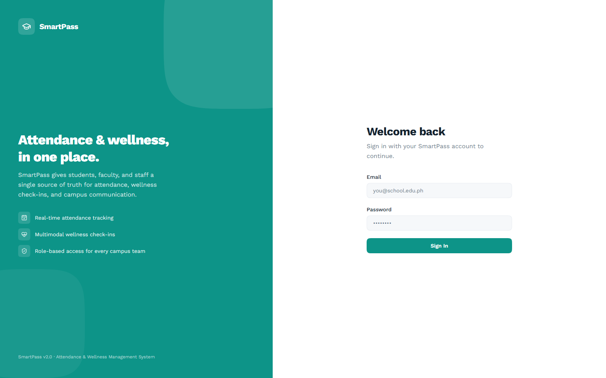
Figure 1. Sign-in screen with role-based authentication
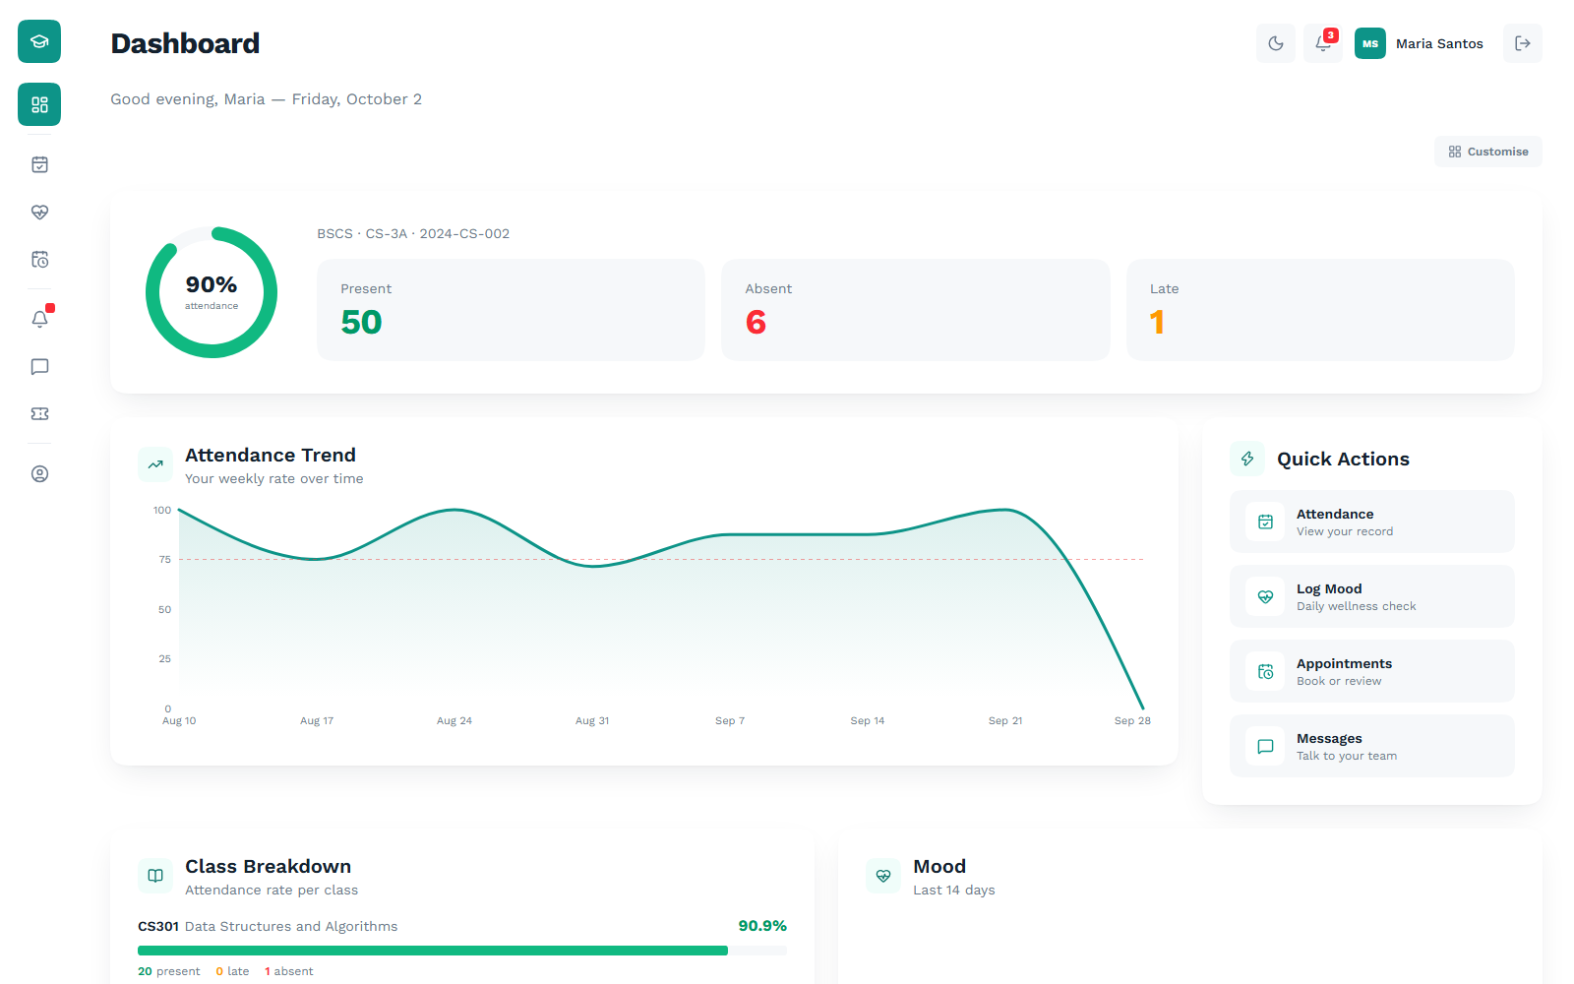
Figure 2. Student dashboard: attendance rate, presence counts, weekly trend and mood history
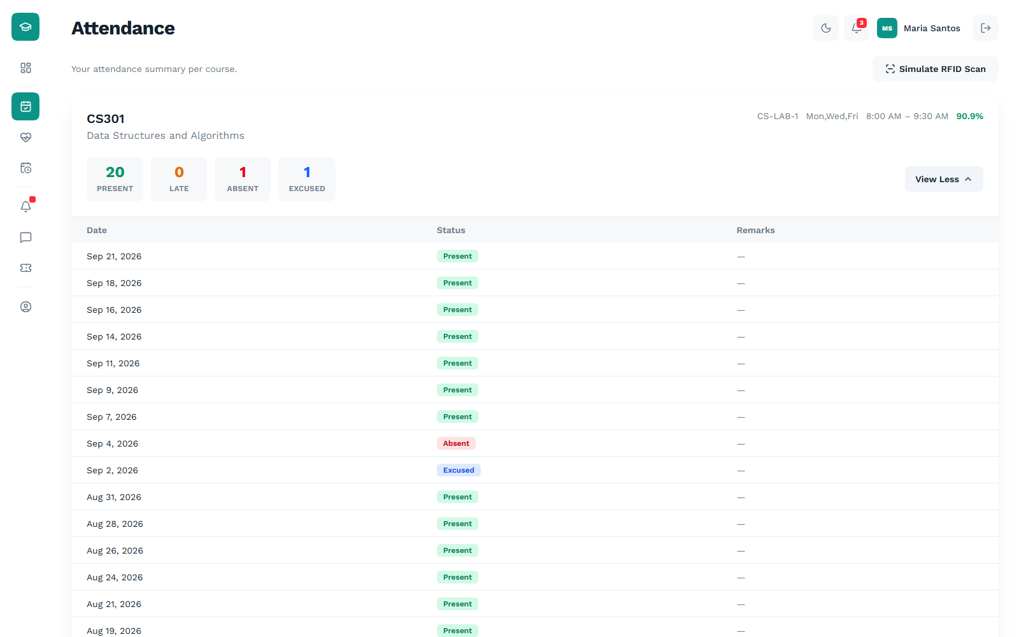
Figure 3. Student attendance: per-course summary with the dated session record expanded
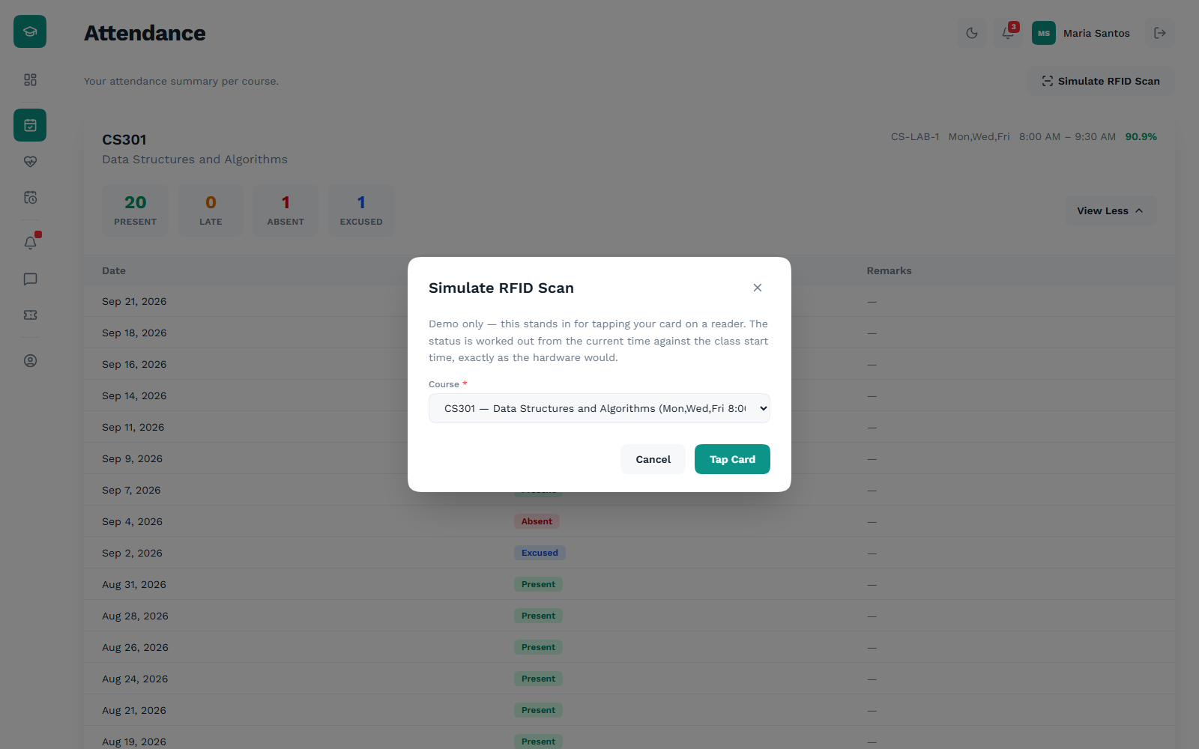
Figure 4. Simulated RFID tap, with the class section selected before logging
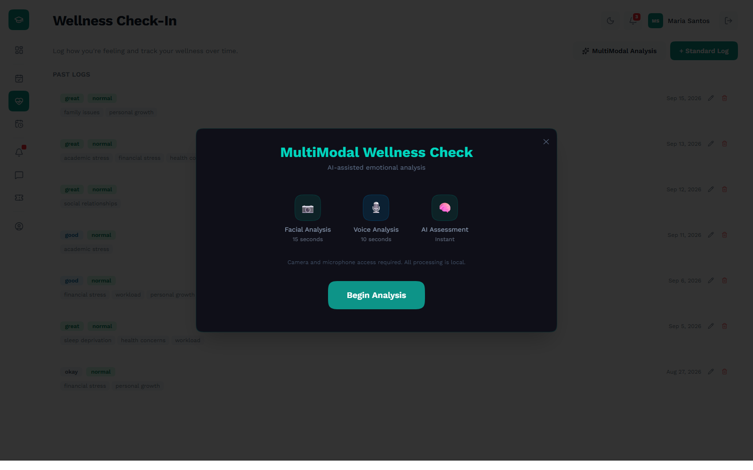
Figure 5. Multi-modal wellness check-in: facial, voice and combined AI assessment
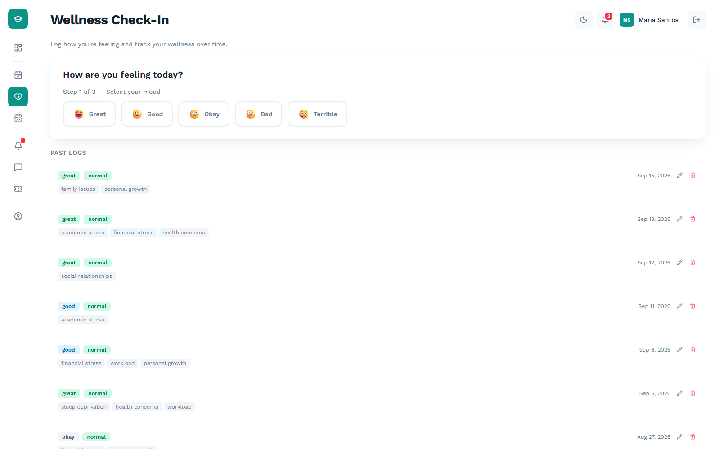
Figure 6. Standard mood check-in, step one of three
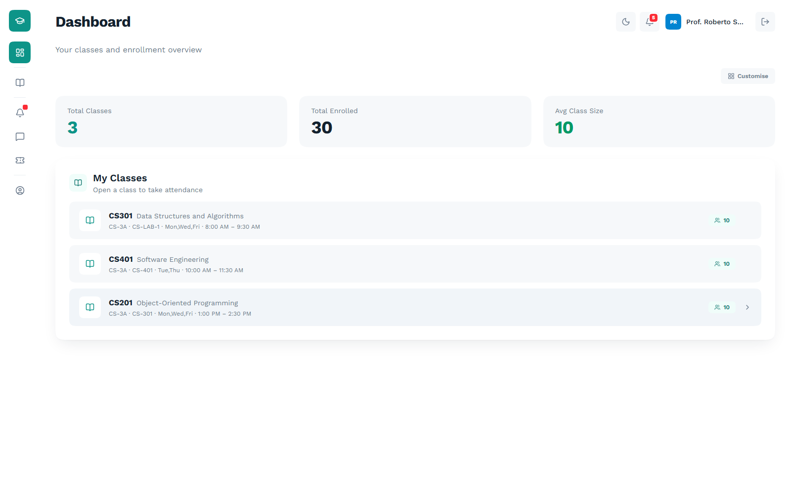
Figure 7. Professor dashboard: class count, total enrollment and average class size
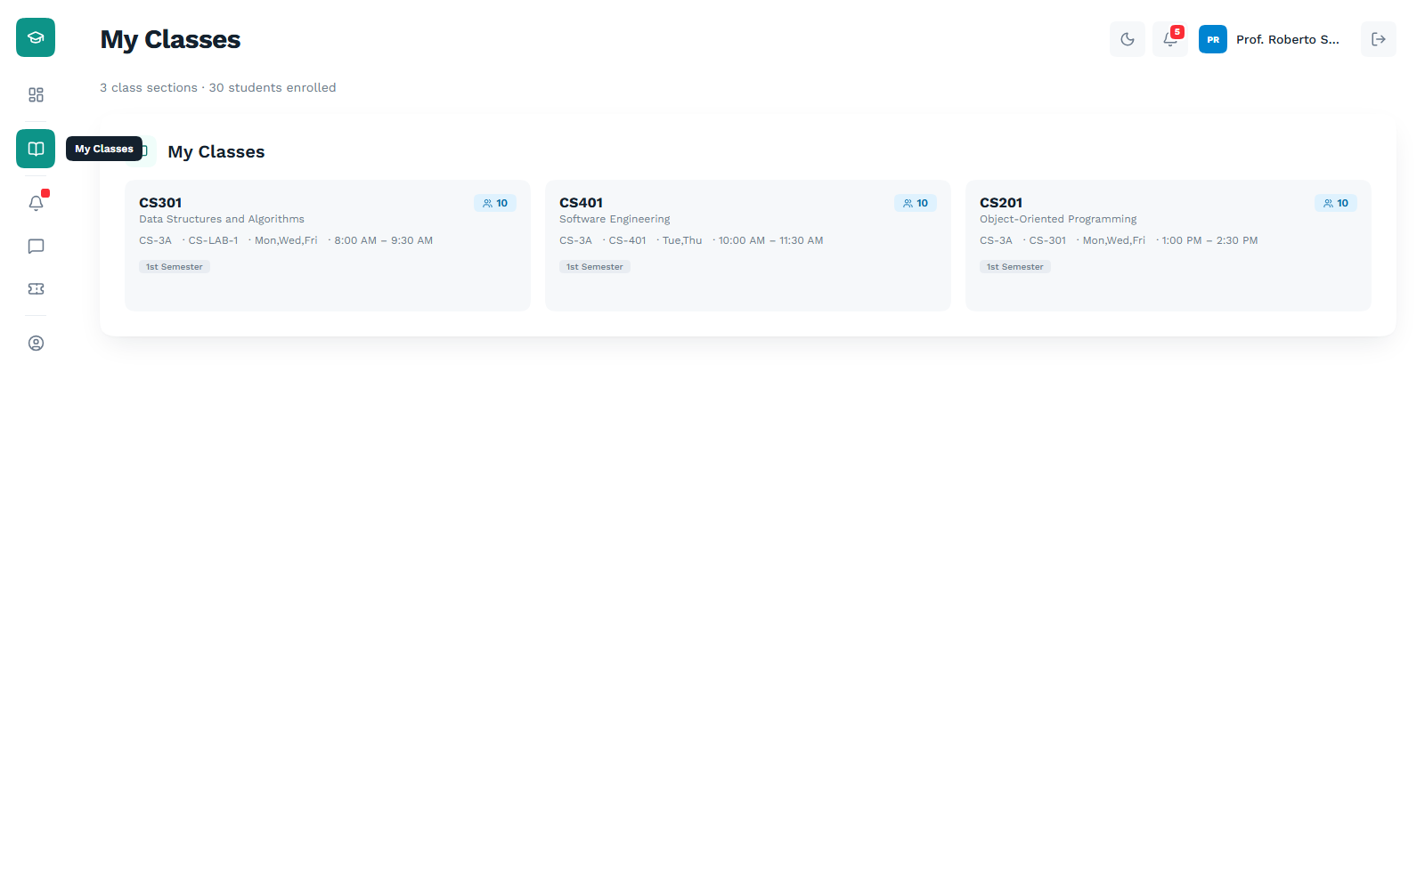
Figure 8. Class sections taught, with enrollment and schedule per section
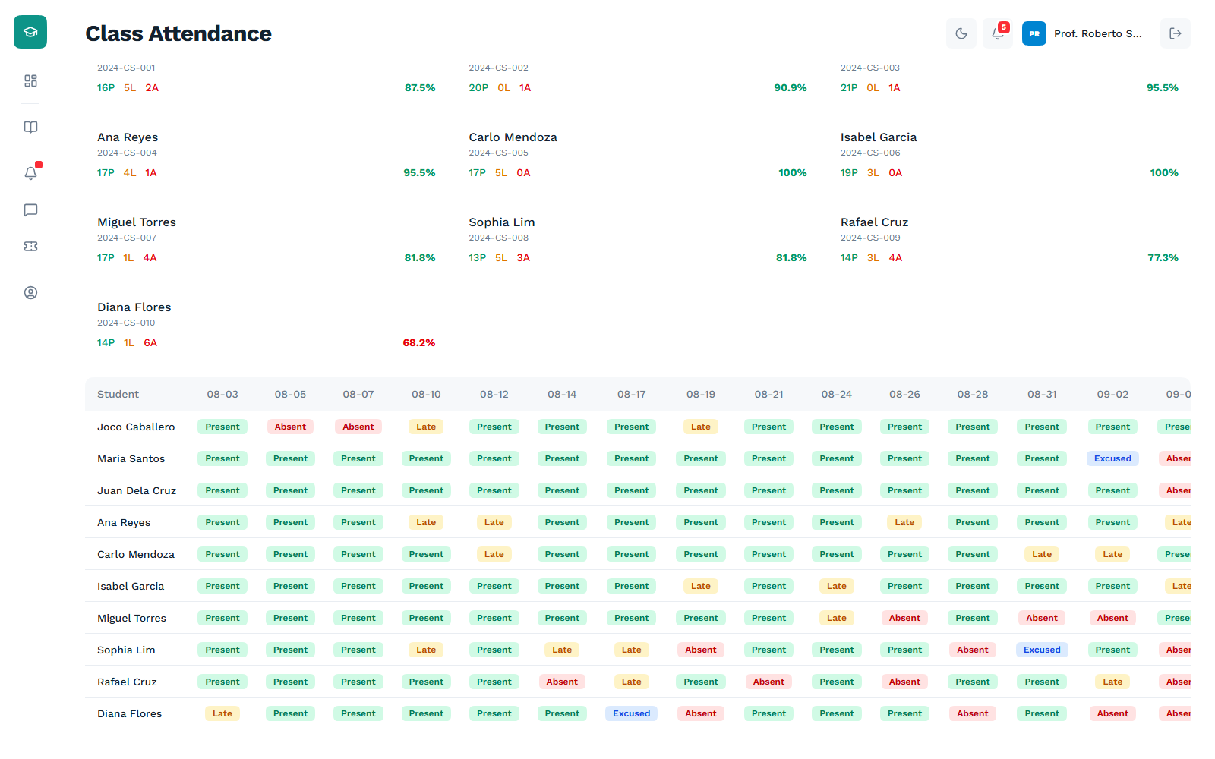
Figure 9. Class attendance matrix: every student against every session, colour-coded by status
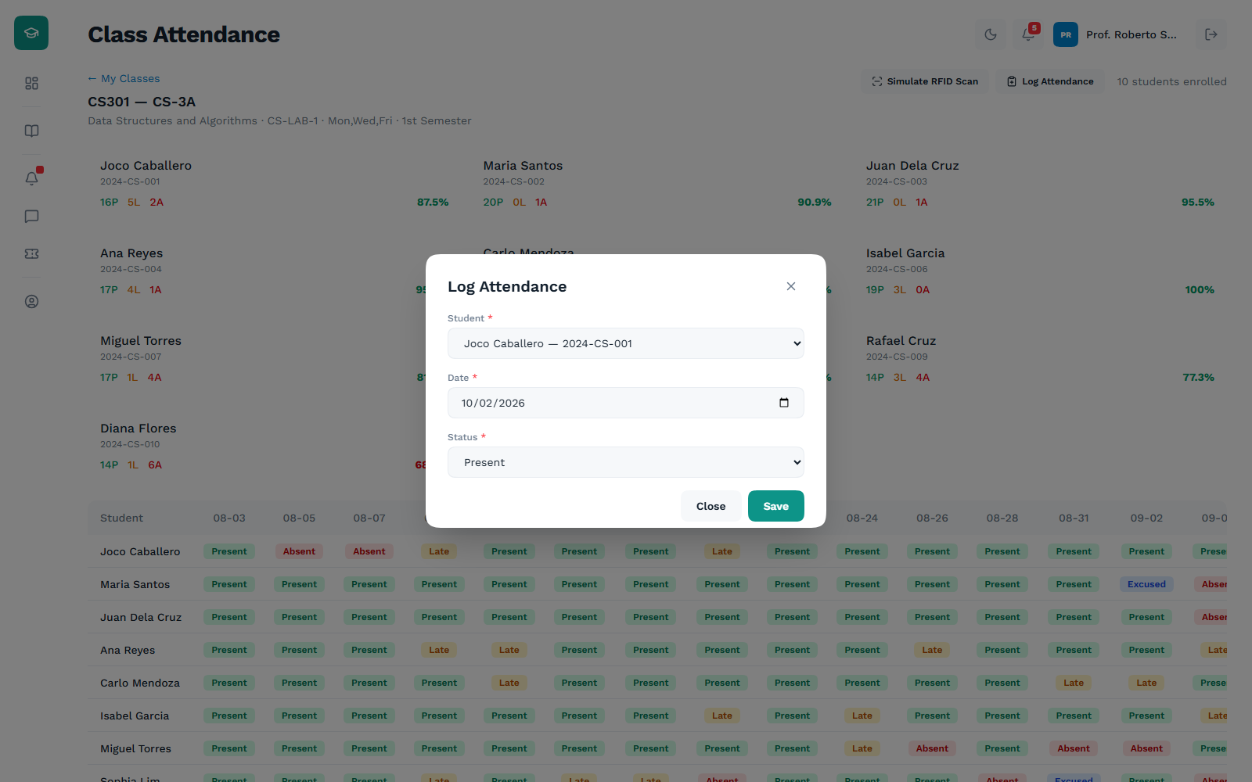
Figure 10. Manual attendance entry for a single student and date
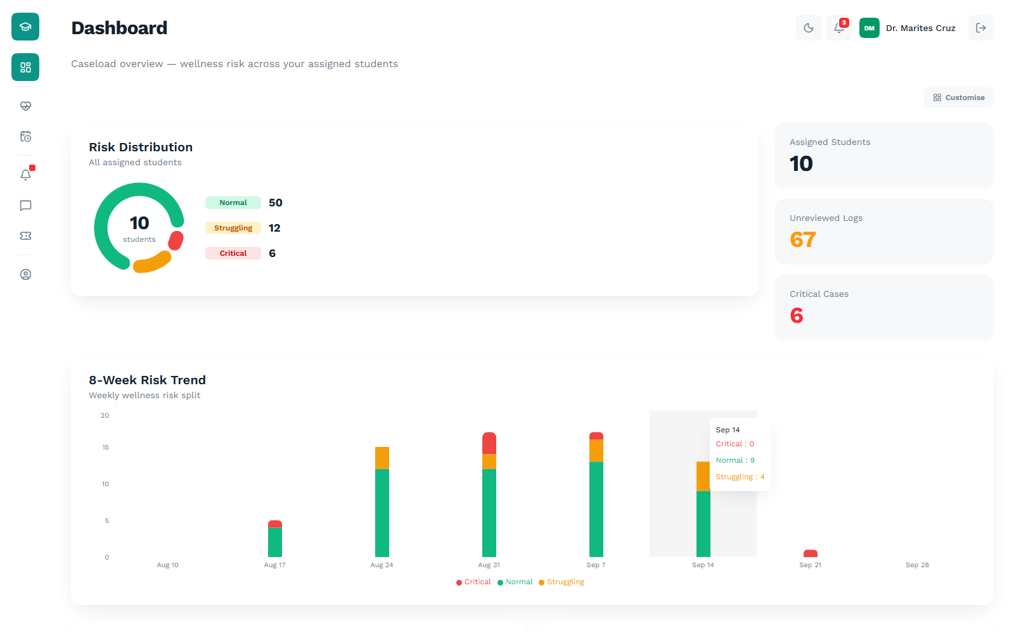
Figure 11. Counselor dashboard: caseload risk distribution and eight-week risk trend
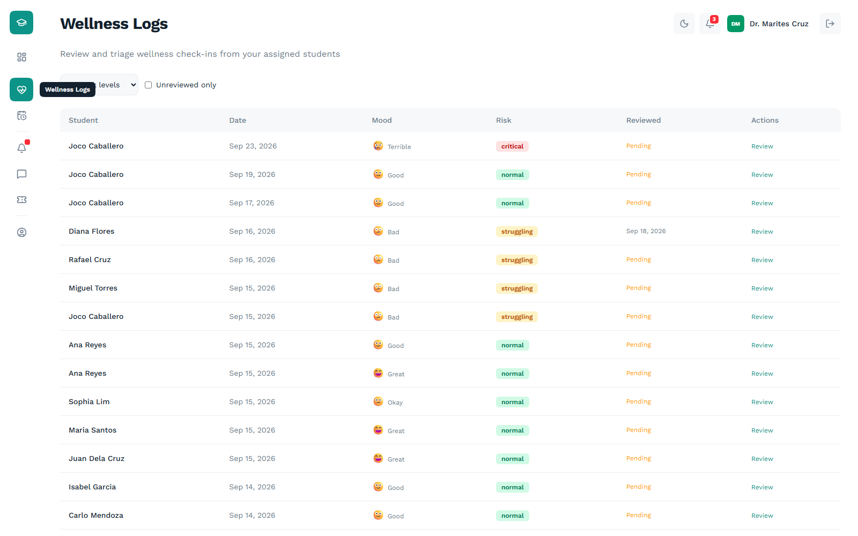
Figure 12. Wellness logs across the assigned caseload, filterable by risk level
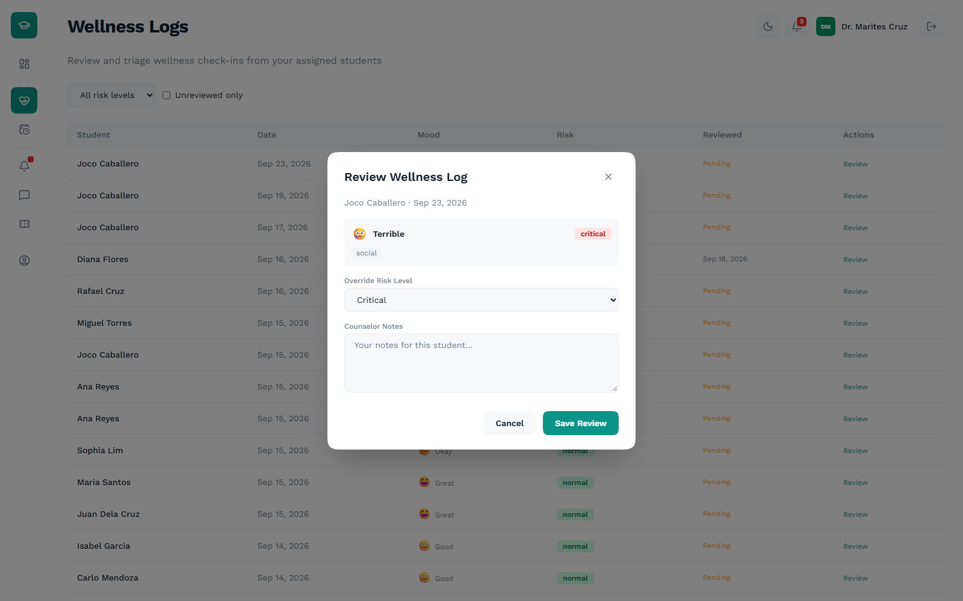
Figure 13. Reviewing a wellness log with a risk override and counselor notes
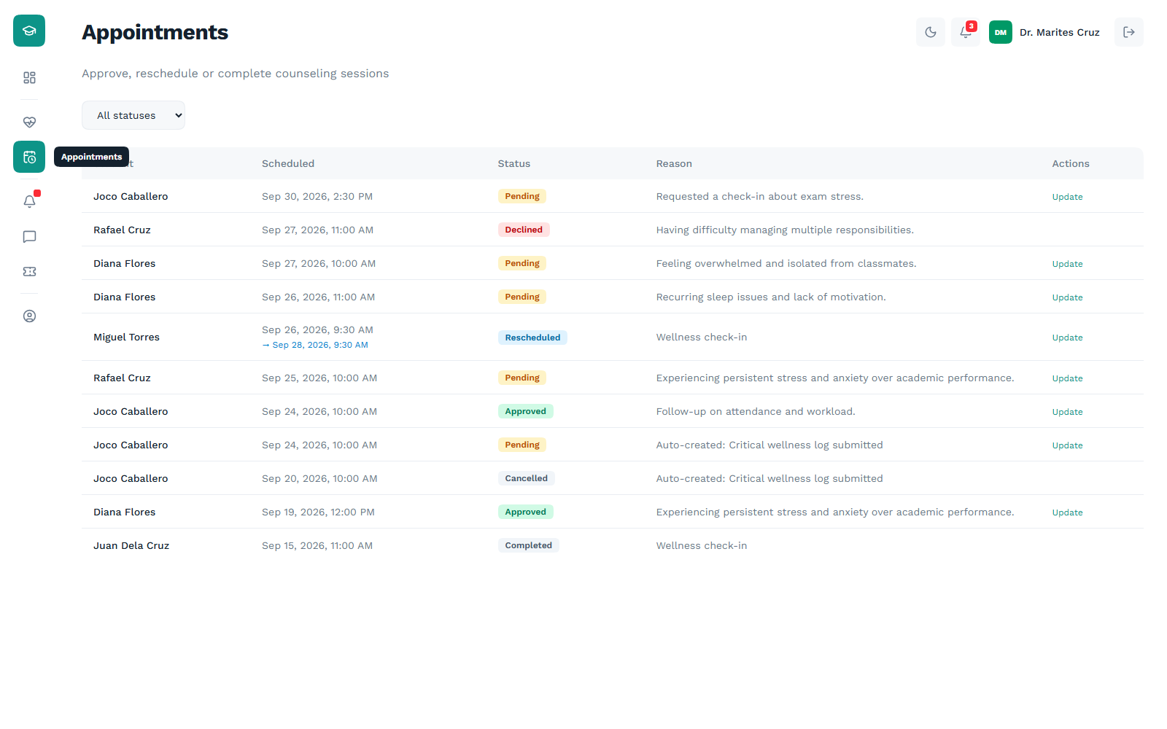
Figure 14. Counseling appointments with full status lifecycle
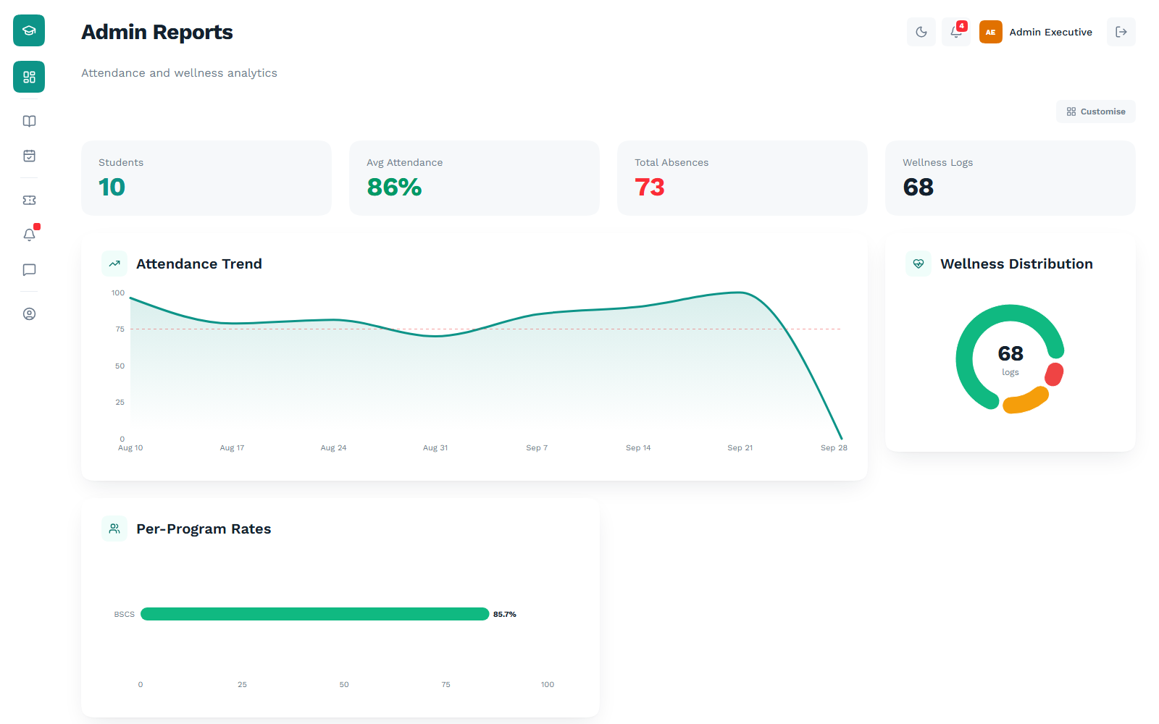
Figure 15. Institution-wide metrics: attendance rate, absences and wellness log volume
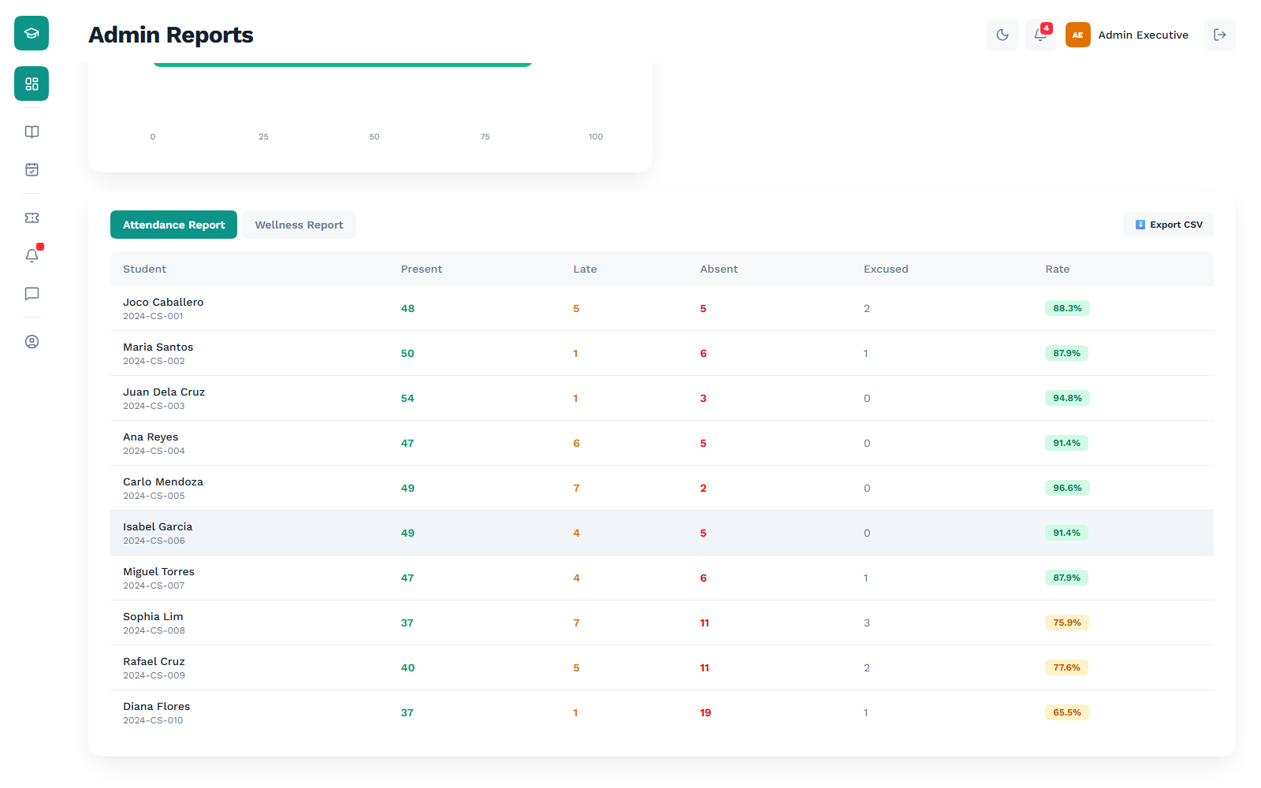
Figure 16. Attendance report by student, switchable to wellbeing reporting
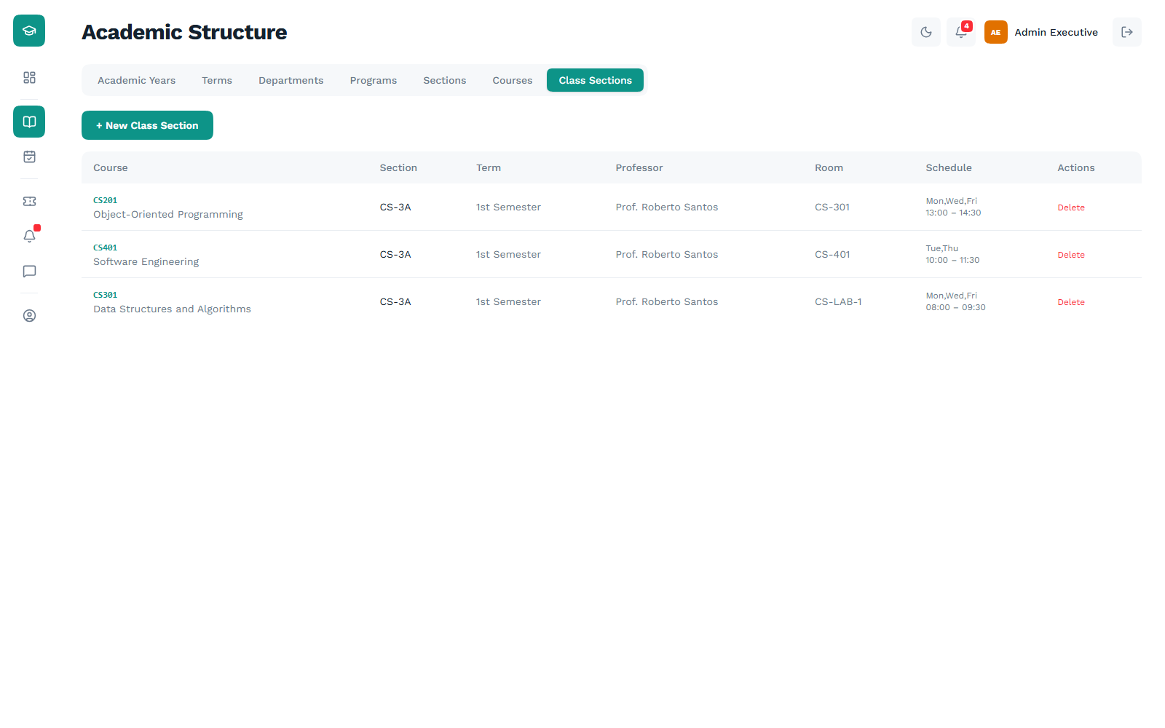
Figure 17. Academic structure: class sections with course, term, professor and schedule
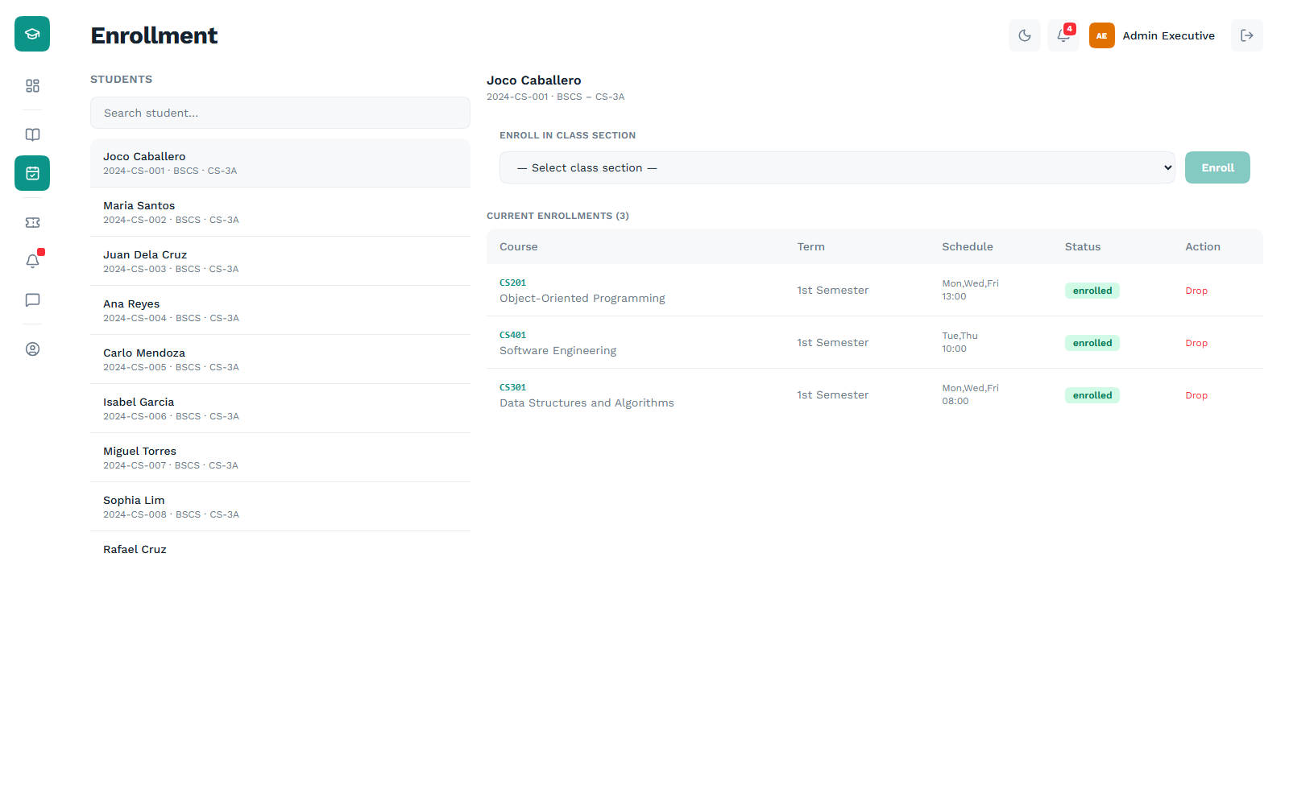
Figure 18. Enrollment management for an individual student
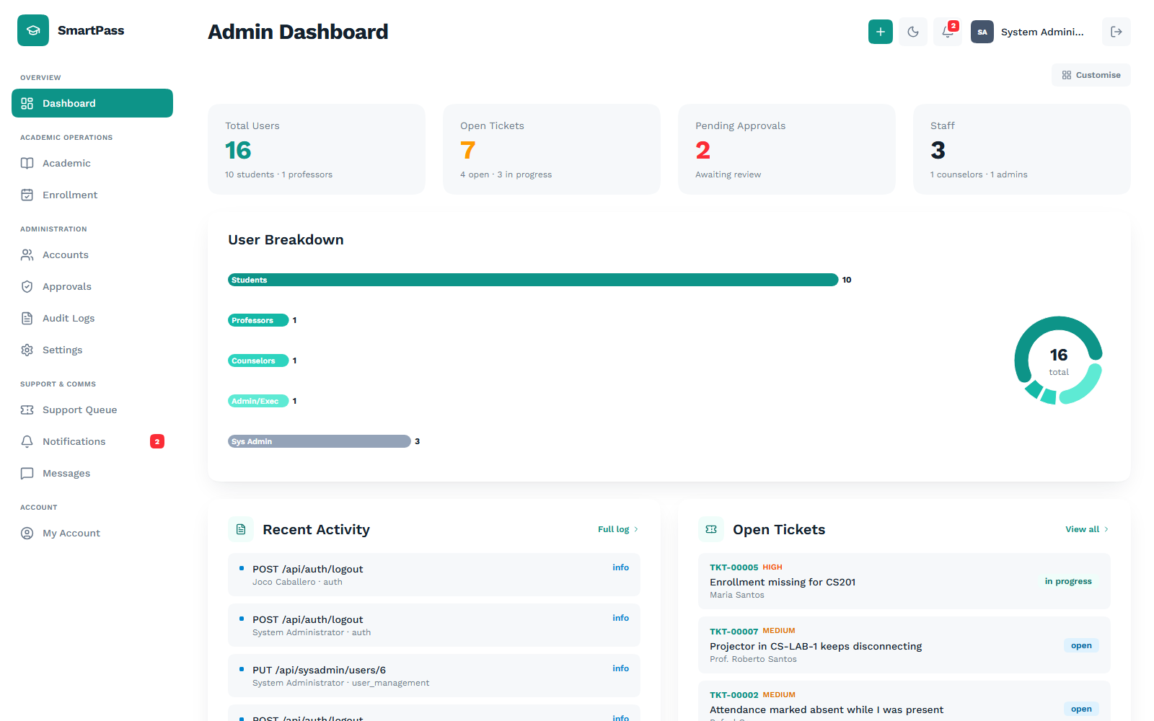
Figure 19. System administrator dashboard: user breakdown, recent activity and open tickets
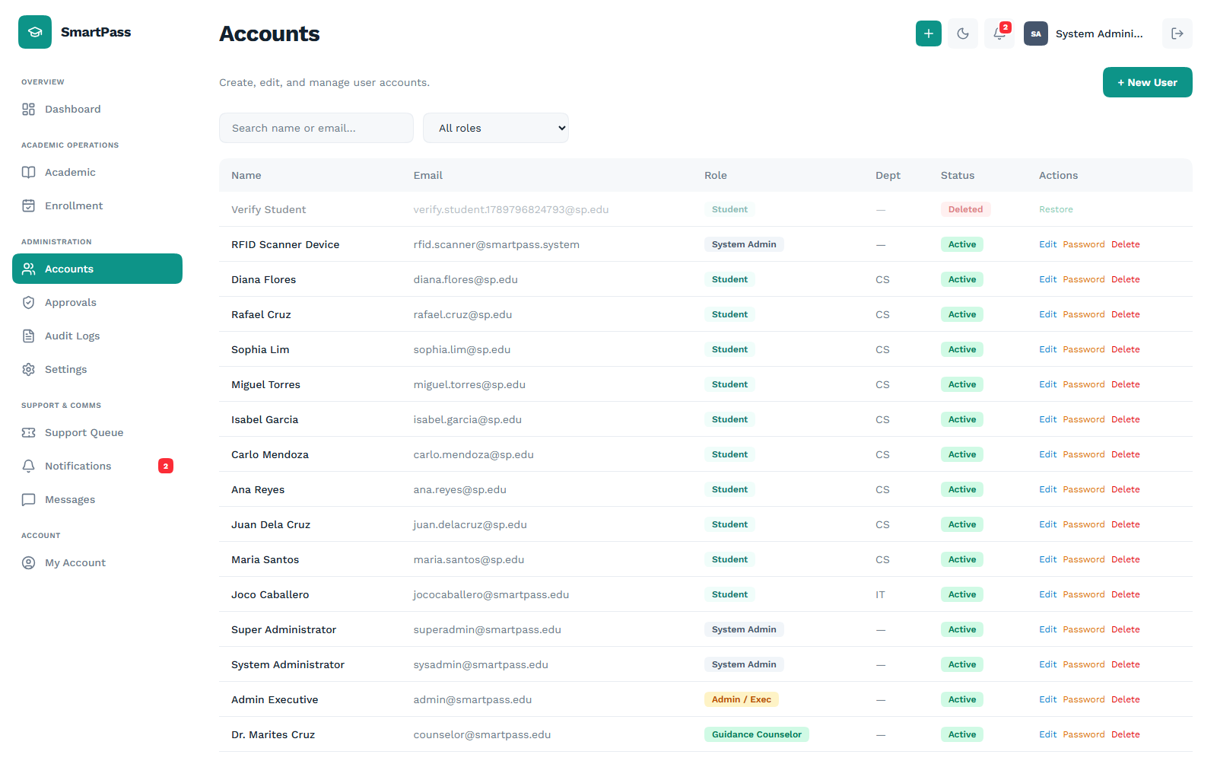
Figure 20. Central account directory with search and role filtering
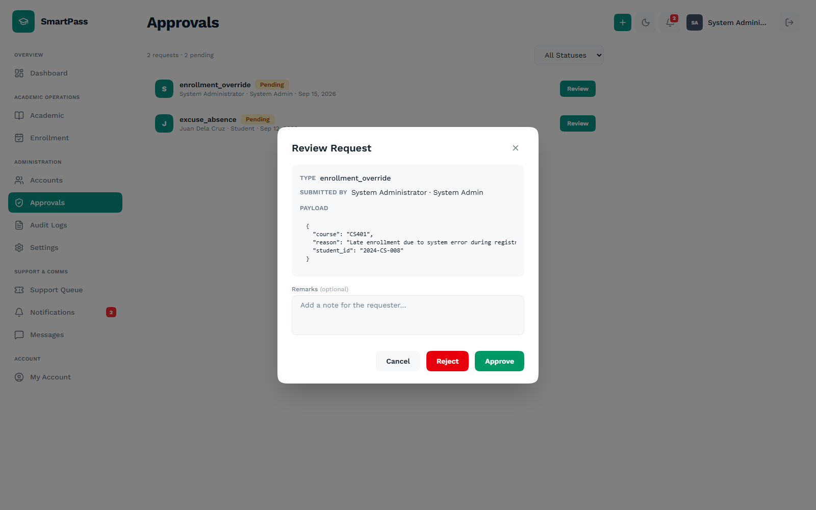
Figure 21. Approval request review showing the full submitted payload
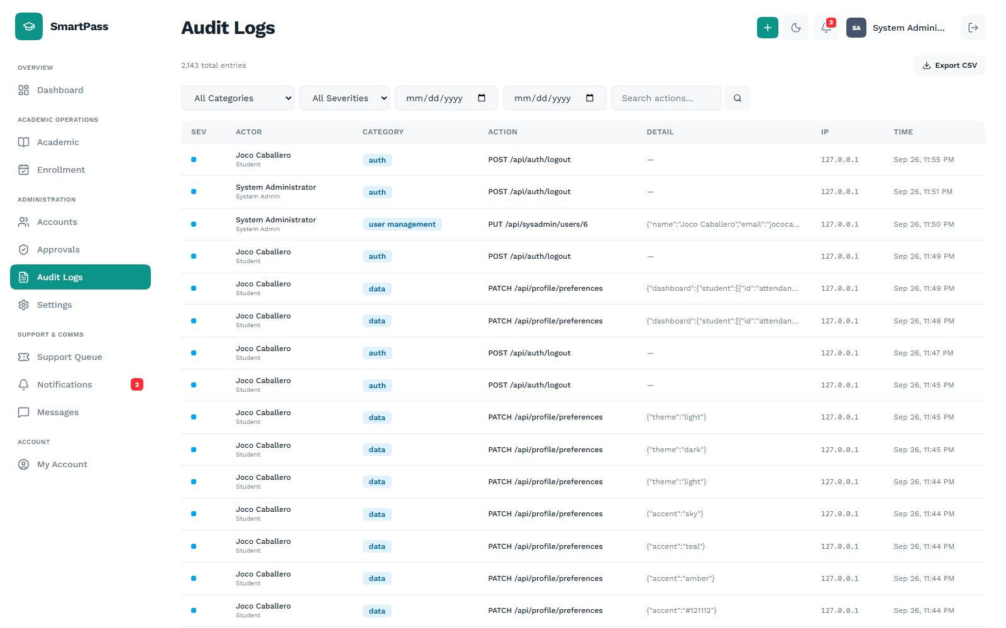
Figure 22. Audit trail of every change, filterable by category, severity and date
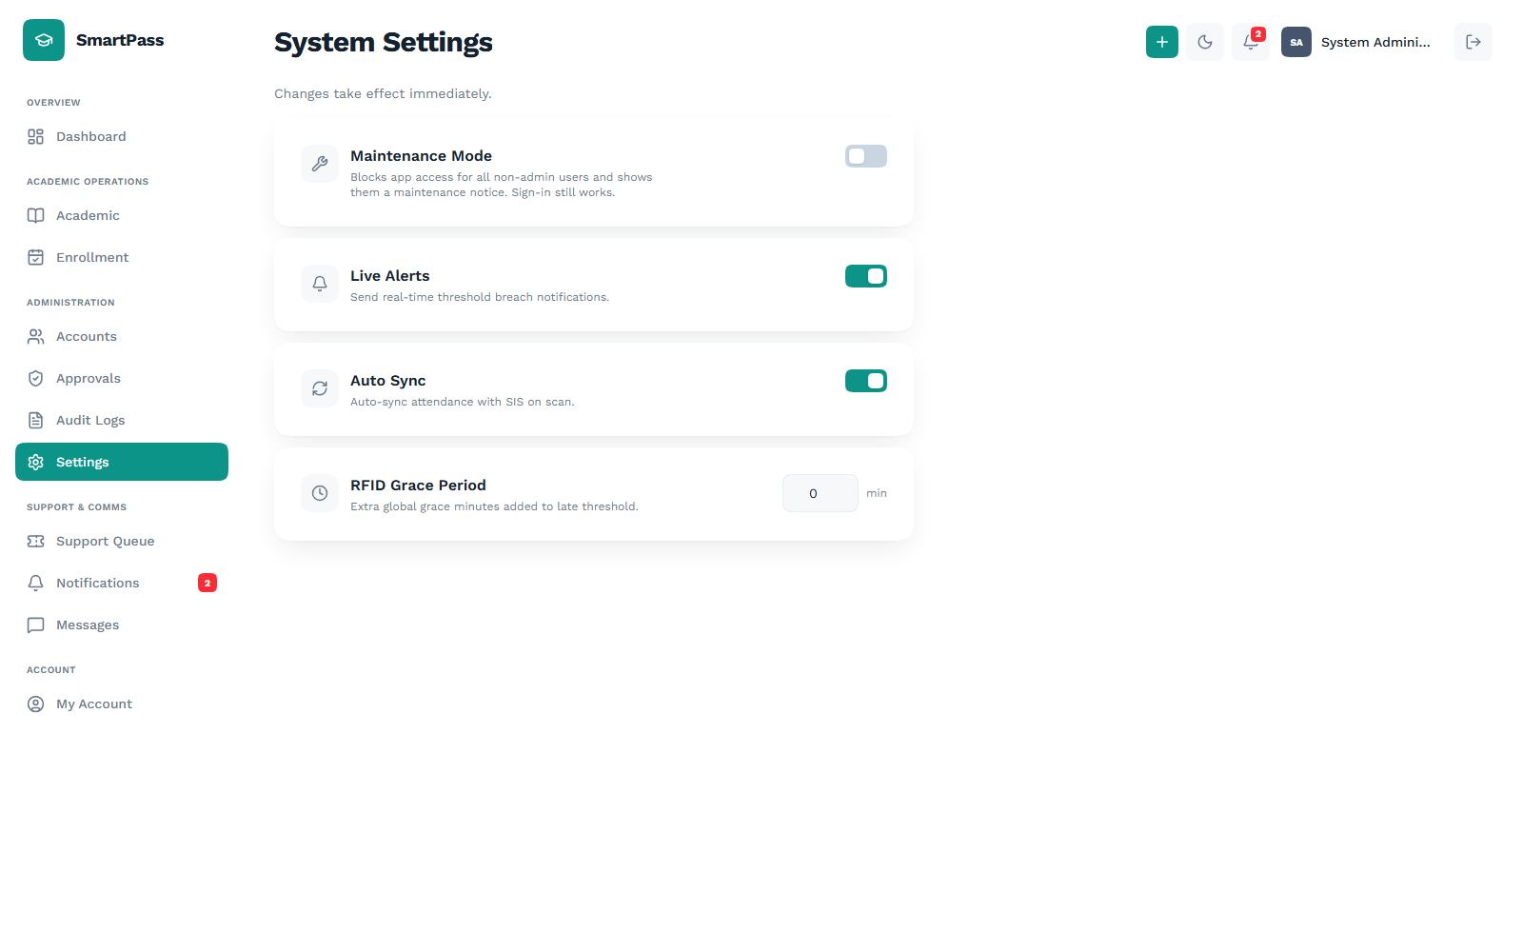
Figure 23. System settings applied live across the platform
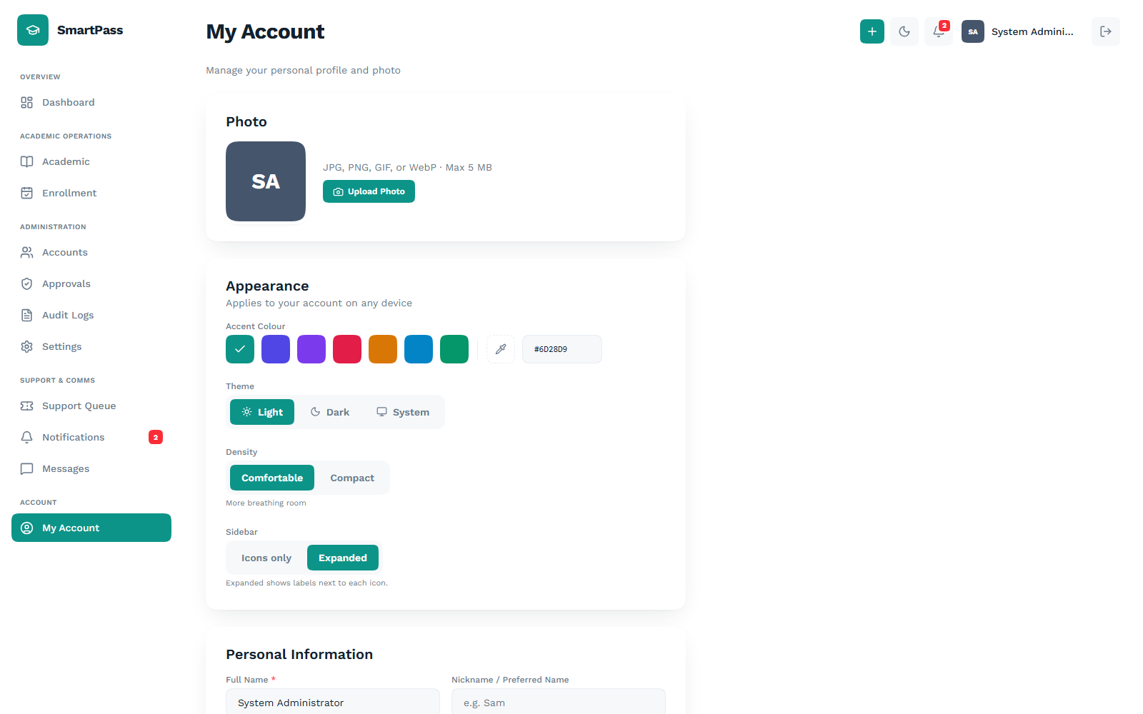
Figure 24. Personalization: accent color, theme, density and sidebar mode

